Assignment 3 – Discrete Random Variables

5.3. Classify each of the following random variables as discrete or continuous:
a. x=the number of girls born to a couple who will have three children.
b. x=the number of defects found on an automobile at final inspection.
c. x=the weight (in ounces) of the sandwich meat placed on a submarine sandwich.
d. x=the number of incorrect lab procedures conducted at a hospital during a particular week.
e. x=the number of customers served during a given day at a drive-through window.
f. x=the time needed by a clerk to complete a task.
g. x=the temperature of a pizza oven at a particular time.
Solution： a. Discrete
b. Discrete
c. Continuous
d. Discrete
e. Discrete
f. Continuous
g. Continuous

5.12. Suppose that the probability distribution of a random variable x can be described by the formula
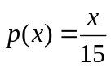
for each of the values X=1,2,3,4, and 5. For example, then 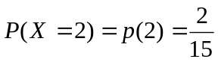.
a. Write out the probability distribution table of x.
b. Show that the probability distribution of x satisfies the properties of a discrete probability distribution.
c. Calculate the mean of x.
d. Calculate the variance,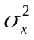, and the standard deviation, 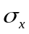.
Solution:
a. x 1 2 3 4 5
p(x) 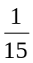 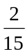 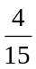
b. p(x) ≥ 0 for each value of x.
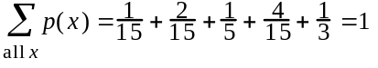
c.
d. 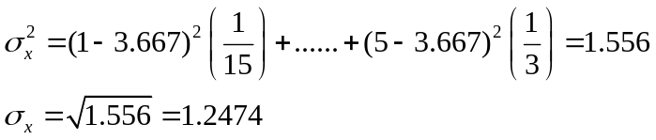

5.24. Thirty percent of all customers who enter a store will make a purchase. Suppose that six customers enter the store and that these customers make independent purchase decisions.
a. Let x=the number of the six customers who will make a purchase. Write the binomial formula for this situation.
b. Use the binomial formula to calculate.
(1) The probability that exactly five customers make a purchase.
(2) The probability that at least three customers make a purchase.
(3) The probability that two or fewer customers make a purchase.
(4) The probability that at least one customer make a purchase.
Solution: a.
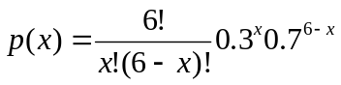
b.
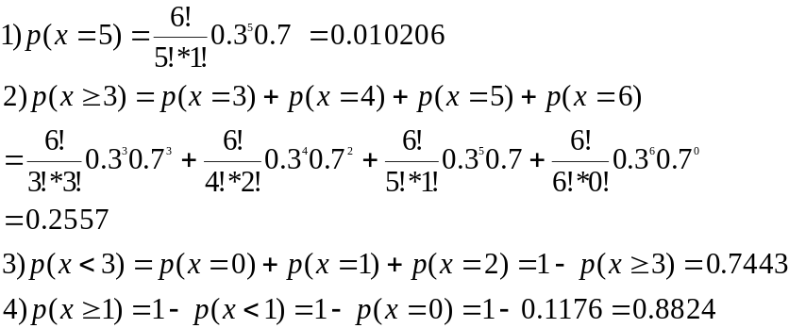

5.48. Suppose that the number of accident occurring in an industrial plant is described by a Poisson process with an average of 1.5 accidents every three months. During the last
three months, four accidents occurred.
a. Find the probability that no accidents will occur during the current three-month period.
b. Find the probability that fewer accidents will occur during the current three-month period than occurred during the last three-month period.
c. Find the probability that no more than 12 accidents will occur during a particular year.
d. Find the probability that no accidents will occur during a particular year.
Solution: (a)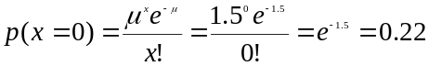
(b) =0.22+0.33+0.25+0.13=0.93
(c)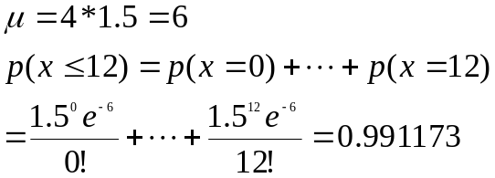
(d) 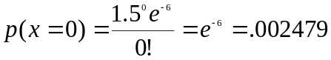

Continuous Random Variables

- Consider the figure given bellow. Find the value k that makes the function f(x) a valid continuous probability distribution.
f(x)
0
5
x
k
Solution: 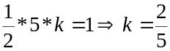

6.36. Two students take a college entrance exam known to have a normal distribution of scores. The students receive raw scores of 63 and 93, which correspond to scores (often called the standardized scores) of  and 1.5, respectively. Find the mean and standard deviation of the distribution of raw exam scores.
Solution: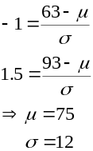

6.40. Suppose that yearly health care expenses for a family of four are normally distribute d with a mean expense equal to $3,000 and a standard deviation of $500. An insurance company has decides to offer a health insurance premium reduction if a policyholder’s health care expenses do not exceed a specified dollar amount. What dollar amount should be established if the insurance company wants families having the lowest 33 percent of yearly health care expenses to be eligible for the premium reduction.
Solution:
P(x ≤ k) = .33
k = 2780
$2780

6.49. When a store uses Electronic article surveillance(EAS) to combat shoplifting, it places a small sensor on an item of merchandise. When an item if legitimately purchased, the sales clerk remove the sensor to prevent the alarm from sounding as the customer exits the store to such false alarms. In an actual survey of 250 consumers, 40 said that if they were to set off an EAS alarm because store personnel (mistakenly) failed to deactivate the merchandise leaving the store, then they would never shop at that store again. A company marketing the alarm system claimed that no more than 5 percent of all consumers would say that they would never shop at that store again if they were subjected to a false alarm.
a. Assuming that the company’s claim is valid, use the normal approximation to the binomial to calculate the probability that at least 40 of the 250 randomly selected consumers would say that they would never shop at that store again if they were subjected to a false alarm.
b. Do you believe the company’s claim based on your answer to part a? Explain.
Solution: a.

(approximately)
b. No, if the claim is true, then 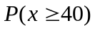 is too small.

